Hello,

Please refer to the below details for my brief introduction.

Phot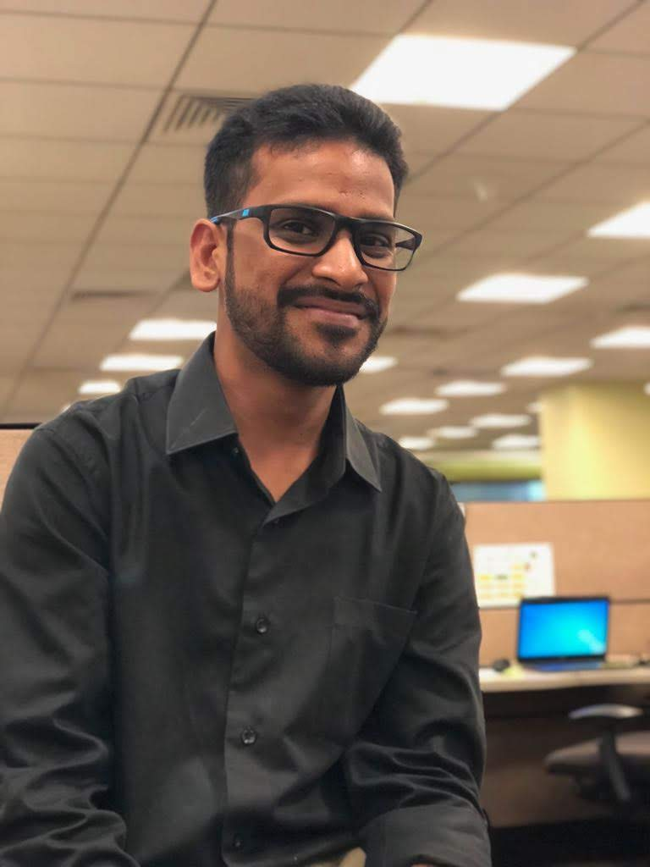o

Deepak Shinghal has 9 years of exposure in supporting and influencing positive outcomes in business units and companies through the application of cutting-edge tools and creation of detailed production-level technical specifications, as well as intuitive conceptual,logical, relational and physical data models.Prior to Accenture he was associated with John Deere.

Deepak Shinghal is a Electronics Engineering from Jaypee Solan (HP) . He is married and is settled in Pune. Deepak Shinghal is exicited about his new journey & is looking forward for a great learning experience with Accenture.